
<!DOCTYPE html>
<html lang="en">
<head>
<meta charset="UTF-8">
<meta name="viewport" content="width=device-width, initial-scale=1.0">
<title>Sierra Leone Football Agency - Home</title>
<link rel="stylesheet" href="style.css">
<link rel="stylesheet" href="https://cdnjs.cloudflare.com/ajax/libs/font-awesome/6.4.0/css/all.min.css">
</head>
<body>
<nav class="navbar">
<div class="container">
<div class="nav-wrapper">
<div class="logo">
<img src="images/LOGO.png" alt="SLFA Logo">
<span>SLFA</span>
</div>
<ul class="nav-menu" id="navMenu">
<li><a href="index.html" class="active">Home</a></li>
<li><a href="players.html">Players</a></li>
<li><a href="matches.html">Matches</a></li>
<li><a href="about.html">About</a></li>
<li><a href="contact.html">Contact</a></li>
</ul>
<div class="hamburger" id="hamburger">
<span></span>
<span></span>
<span></span>
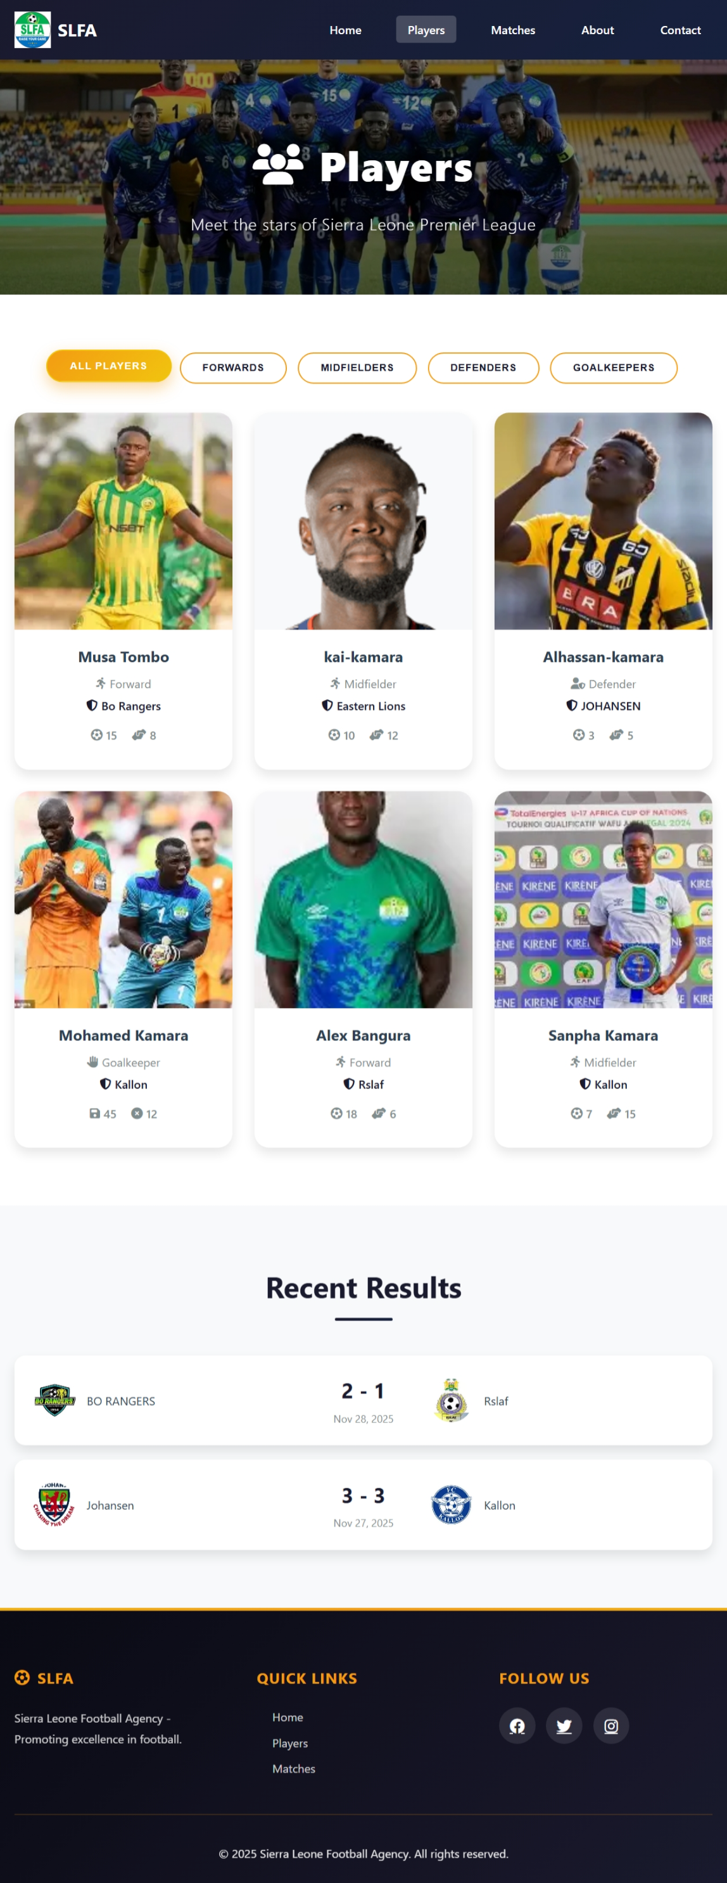
<!DOCTYPE html>
<html lang="en">
<head>
<meta charset="UTF-8">
<meta name="viewport" content="width=device-width, initial-scale=1.0">
<title>Players - Sierra Leone Football Agency</title>
<link rel="stylesheet" href="style.css">
<link rel="stylesheet" href="https://cdnjs.cloudflare.com/ajax/libs/font-awesome/6.4.0/css/all.min.css">
</head>
<body>
<nav class="navbar">
<div class="container">
<div class="nav-wrapper">
<div class="logo">
<img src="images/LOGO.png" alt="SLFA Logo">
<span>SLFA</span>
</div>
<ul class="nav-menu" id="navMenu">
<li><a href="index.html">Home</a></li>
<li><a href="players.html" class="active">Players</a></li>
<li><a href="matches.html">Matches</a></li>
<li><a href="about.html">About</a></li>
<li><a href="contact.html">Contact</a></li>
</ul>
<div class="hamburger" id="hamburger">
<span></span>
<span></span>
<span></spa
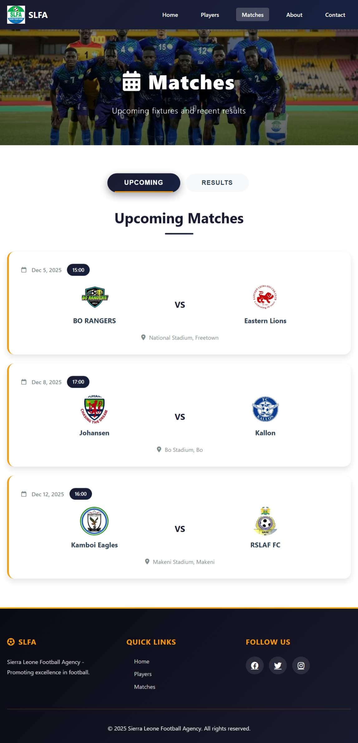
<!DOCTYPE html>
<html lang="en">
<head>
<meta charset="UTF-8">
<meta name="viewport" content="width=device-width, initial-scale=1.0">
<title>Matches - Sierra Leone Football Agency</title>
<link rel="stylesheet" href="style.css">
<link rel="stylesheet" href="https://cdnjs.cloudflare.com/ajax/libs/font-awesome/6.4.0/css/all.min.css">
</head>
<body>
<nav class="navbar">
<div class="container">
<div class="nav-wrapper">
<div class="logo">
<img src="images/LOGO.png" alt="SLFA Logo">
<span>SLFA</span>
</div>
<ul class="nav-menu" id="navMenu">
<li><a href="index.html">Home</a></li>
<li><a href="players.html">Players</a></li>
<li><a href="matches.html" class="active">Matches</a></li>
<li><a href="about.html">About</a></li>
<li><a href="contact.html">Contact</a></li>
</ul>
<div class="hamburger" id="hamburger">
<span></span>
<span></span>
<span></s
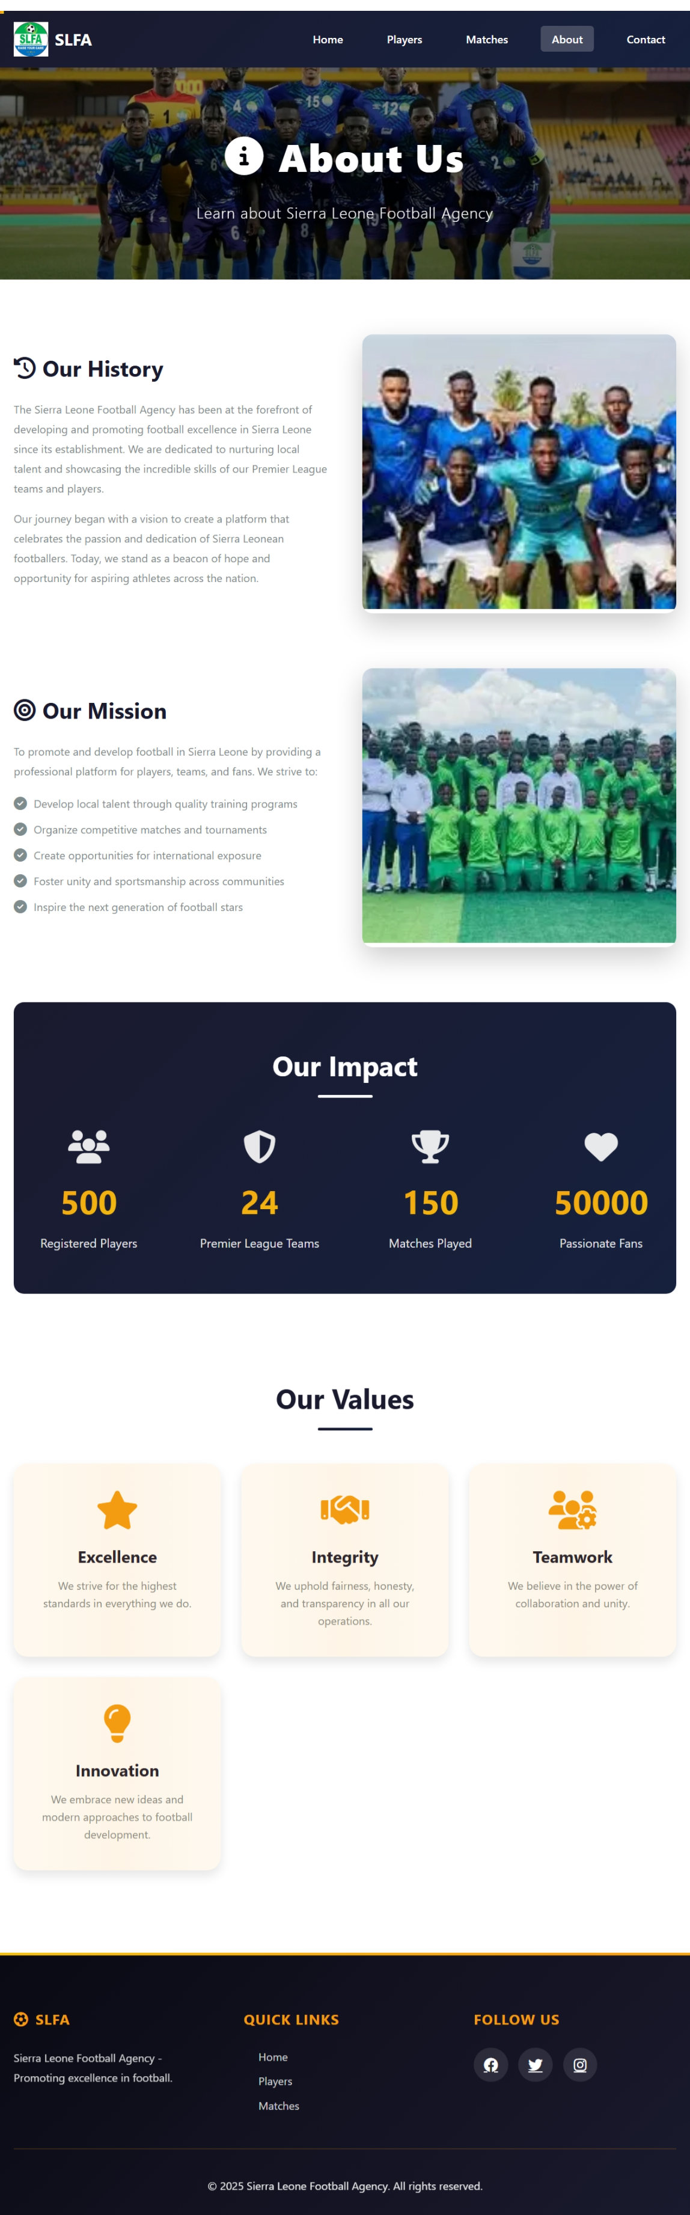
<!DOCTYPE html>
<html lang="en">
<head>
<meta charset="UTF-8">
<meta name="viewport" content="width=device-width, initial-scale=1.0">
<title>About - Sierra Leone Football Agency</title>
<link rel="stylesheet" href="style.css">
<link rel="stylesheet" href="https://cdnjs.cloudflare.com/ajax/libs/font-awesome/6.4.0/css/all.min.css">
</head>
<body>
<nav class="navbar">
<div class="container">
<div class="nav-wrapper">
<div class="logo">
<img src="images/LOGO.png" alt="SLFA Logo">
<span>SLFA</span>
</div>
<ul class="nav-menu" id="navMenu">
<li><a href="index.html">Home</a></li>
<li><a href="players.html">Players</a></li>
<li><a href="matches.html">Matches</a></li>
<li><a href="about.html" class="active">About</a></li>
<li><a href="contact.html">Contact</a></li>
</ul>
<div class="hamburger" id="hamburger">
<span></span>
<span></span>
<span></span>
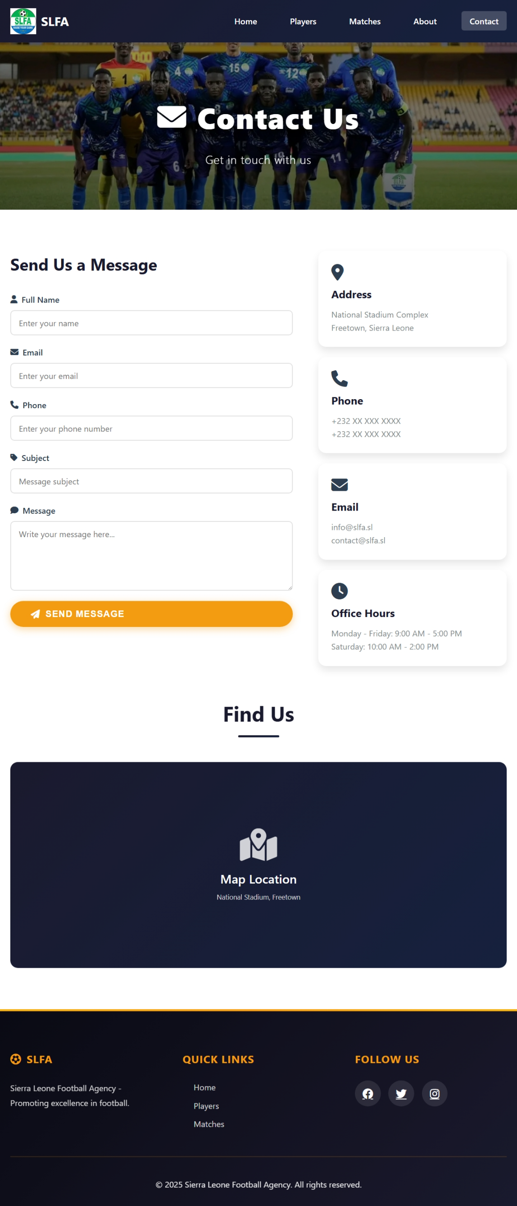
<!DOCTYPE html>
<html lang="en">
<head>
<meta charset="UTF-8">
<meta name="viewport" content="width=device-width, initial-scale=1.0">
<title>Contact - Sierra Leone Football Agency</title>
<link rel="stylesheet" href="style.css">
<link rel="stylesheet" href="https://cdnjs.cloudflare.com/ajax/libs/font-awesome/6.4.0/css/all.min.css">
</head>
<body>
<nav class="navbar">
<div class="container">
<div class="nav-wrapper">
<div class="logo">
<img src="images/LOGO.png" alt="SLFA Logo">
<span>SLFA</span>
</div>
<ul class="nav-menu" id="navMenu">
<li><a href="index.html">Home</a></li>
<li><a href="players.html">Players</a></li>
<li><a href="matches.html">Matches</a></li>
<li><a href="about.html">About</a></li>
<li><a href="contact.html" class="active">Contact</a></li>
</ul>
<div class="hamburger" id="hamburger">
<span></span>
<span></span>
<span></sp

